FREE UNIVERSITY OF BOZEN-BOLZANO

FACULTY OF COMPUTER SCIENCE

**Why Hardware Startups Fail**

Heider Jeffer

February 2022

Supervisor: Xiaofeng Wang

Submitted for the degree of the Master of Software Engineering.

**Acknowledgments**

Throughout the writing of this dissertation, I have received a great deal of support and assistance.

I would first like to thank my supervisor, Professor Xiaofeng Wang, whose expertise was invaluable in formulating the research questions and methodology. Your insightful feedback pushed me to sharpen my thinking and brought my work to a higher level.

Xiao, I want to thank you for your patient support and all the opportunities I was given to further my research. I want to acknowledge my colleagues at the great Faculty of Design and Art - at the Free University of Bozen-Bolzano for their wonderful collaboration. I would like to mention my supervisor at the Free University of Bozen-Bolzano, Professor Xiaofeng Wang.

I would also like to thank my giant tutors, Professor Gabriella Dodero, Professor Sven Helmer, and Professor Gennari Rosella, for their valuable guidance throughout my studies. They gave me the tools to choose the right direction and complete my dissertation.

In addition, I would like to thank All UNIBZ Staff, Student secretaries, UNI-BAR, UNIBZ Library, Security, and UNIBZ ICT Services. You are always there for students and hard-working keeping our UNIBZ alive.

I could not have completed this dissertation after surviving the Iraq endless war without the strong support of UNHCR in my exile and the health care support of the white army Ministry of Health of Italy, nurses, surgeons, and doctors at Bozen Hospital to cure war wounded, and during their giant works during COVID-19 Pandemic for their free guidelines, apps, and VAX, they risk their lives to save humans lives.

I could not be accepted here at UNIBZ without the support of Prof. Paolo Lugli, our Rector, and Prof. Ulrike Tappeiner, our great President, which I never met, but reading: "Charter of Rights and Responsibilities of Students at the Free University of Bozen- Bolzano."

**This paper is dedicated to the following:**

My small family, my mother, and my Tribes inside and outside Iraq, the Great City of Baghdad and Mesopotamia gave me the possibility to pursue my university studies. They believed in me all these four years.

To the people of Mesopotamia, the homeland of the apostles and prophets, the cradle of civilization, crafters of writing, and home of enumeration. Upon our land, the first law made by man was passed, and the oldest part of just governance was inscribed, and upon our soil, the saints and companions of the Prophet prayed, philosophers and scientists theorized, and writers and poets excelled.

**Plagiarism Disclaimer**

I Heider Jeffer, I hereby declare and confirm with my signature that this dissertation is my own original and autonomous work. All sources and aids used have been indicated as such. All texts, either quoted directly or paraphrased, have been indicated by in-text citations.

Full bibliographic details are given in the reference list, which also contains internet website(s) sources containing URL, Theme nodes, Case Study in NVivo Software in Doc format, Content Analysis NVivo software PDF format, Heider Jeffer at Mendeley and access data.

I also declare that no part of the paper submitted has been made inappropriately, whether by plagiarizing or infringing on any third person's copyright.

I declare that no part of the paper submitted has been used for any other paper, higher education institution, research institution, or educational institution.

Finally, I declare that this research is open-source Copyleft research with an MIT license. The laboratory part of the research, such as codes, materials, Software, and database, is available on the official research repository Gilgamesh at GitHub.

Bolzano, Italy 2022

Heider Jeffer

**" Those who can see beyond the shadows and lies of their culture will never be understood, let alone believed, by the masses."**

**Plato**

**” Fasten the throne [first], then engrave [it].”**

**" In mathematics, you don't understand things. You just get used to them."**

**John von Neumann**

**Abstract**

* **Problem Statement:** Hardware startups often fail. It is still based on trial-and-error, intuition, and individual convenience, without any scientific paper, scientific models, or theoretical foundation that could address an answer for why hardware startups fail to improve the future of the hardware startups and the startups in general.
* **Research objective:** The major research question answered in this thesis is: why hardware startups fail. This thesis developed strategy to extract the factors that cause the failure of hardware startups.
* **Approach:** I used CB-Insights and Gray Literature to collect the secondary data. I developed a strategy to process the data collection and data analysis related to the research question. I include the relevant data and exclude the irrelevant; I used Thematic analysis tools to extract case studies from included data and failure factors from case studies. I extract hardware startup information from the case study. Finally, I grouped the failure factors into identical categories. I store the study material in the research's official repository named Gilgamesh on GitHub.
* **Research Finding:** I find Customer & Market, Hardware Product & Experts, Financial, Lack of Business Model, and Legal Issues; are the major categories that cause the failure of hardware startups. Product strategy mistakes is the most frequent fatal failure factor that reflects the complexity of hardware startups. Pricing Cost Issues: is the factor that explains why hardware startups are challenging and often fail.
* **Contribution:** Lack of previous study can serve as an important opportunity to describe the need for further research. The secondary data of this study can be helpful for IoT, Data Science, companies, and institutions relying on hardware startups or Qualitative Data Analysis. Furthermore, this study also suggests clear guidelines; to follow strategy to process the data to accomplish the thematic analysis.
* **Future Work:** I propose the significant factors that caused the failure of hardware startups. However, I could still improve the research depth and width by considering the Thematic Analysis for Video and Audio Data to extract study cases and failure factors from video and audio format and adjusting search keywords of the Gray Literature to include the A.I. and IoT hardware startups in the data collection.

**Keywords:** hardware startups, failure factors, Gray literature, case study

**Contents**

1 Introduction 12

1.1 Problem and Motivation 12

1.2 Research Process and results 13

1.2.1 Data collection and data analysis 13

1.2.2 Results, limitations, and implications for future research 13

1.3 Thesis Structure 15

2 Background and Related Work 16

2.1 What is Hardware Startup 16

2.2 Why Startup Fail 16

2.3 Studies on Hardware Startups 18

2.4 Related Work on Hardware Startups Failure 18

3 Research Approach 19

3.1 Phase 1: Data Collection 21

3.2 Phase 2: Data Analysis 22

3.3 Phase 3: Gilgamesh 23

4 Research Finding 24

4.1 The Major Failure Factors for Hardware Startups 24

4.2 Failure Factors Explained with Exemplar Cases 24

4.2.1 Competition 24

4.2.2 Ignore Customers 25

4.2.3 Lack of demand 25

4.2.4 Lack of interest after initial crowdfunding 26

4.2.5 Poor Marketing 26

4.2.6 Domain Expertise 27

4.2.7 Lose Focus No Plan 27

4.2.8 Manufacturing setbacks 27

4.2.9 Poor Product 28

4.2.10 Product Mis-Timed 28

4.2.11 Product strategy mistakes 28

4.2.12 High burn rate 29

4.2.13 No Financing or Interested Investors 30

4.2.14 Pricing Cost Issues 30

4.2.15 Ran Out of Cash 30

4.2.16 Lack Business Model 31

4.2.17 Legal Issues 31

5 Discussion 32

5.1 Most Critical Hardware Startup Failure Factors 32

5.2 Limitations of the study 32

5.2.1 Lack of previous research studies on Hardware startups failures 32

5.2.2 Gray Literature’s Secondary and Self-reported Data Collection 32

6 Conclusions, implications of the study and directions for future research 33

6.1 Conclusion 33

6.2 Implications for future research 33

6.2.1 Implications on thematic data analysis with video and audio 33

6.2.2 Implications on Adjusting Search Keywords in Gray Literature 33

7 Bibliography 34

8 APPENDIX 37

8.1 PAPER-PROTOTYPE 37

8.2 Data collection and Data Analysis with NVivo Software 39

8.3 Data of [Case Collection B] 46

**List of figures**

Figure ‎2‑1 Startups Diagram 16

Figure ‎3‑1 Data collection and analysis 20

Figure ‎3‑2 Diagram from Gilgamesh Case studies and Failure Factors(Atlas ti version) 23

Figure ‎3‑3 Gilgamesh user interface in local machine 23

**List of tables**

Table ‎2‑1 2018 - 2021: variation of CB-Insights failure factors 17

Table ‎3‑1 Define and refine search keywords 21

Table ‎4‑1 Seventeen Failure Factors assigned in Five Failure Categories 24

**List of Appendix**

A 1 Paper-prototype - first activity 37

A 2 Paper-prototype - second activity - Processing the Data Collection 38

A 3 Data Analysis: 38 Case in [Case Collection A] - NVivo 39

A 4 NVivo: 52 Content Analysis 40

A 5 Future Work: Coding the 52 Content Analysis, NVivo 41

A 6 17 failure factors extracted from 38 case study, NVivo 42

A 7 Groping 17 failure factors into 5 major categories, NVivo 43

A 8 Extracting Hardware Startups Fail information, NVivo 44

A 9 Future Work: including video and audio in the data collection 45

# Introduction

## Problem and Motivation

The research question addressed in this paper is:   
R.Q.: Why Do Hardware Startups Fail?  
Research Objective:  
Developing sets of logical steps and rules  
To Process, Collect, Analyze, Manage & Extract the Failure Factors from Any Given Data Size, Structure, and Formats

Startups are projects to create products or services and look for ongoing business models to sell the product and profit from it under uncertainty and extreme [1] [2] .

Hardware startups are startups that build everything that has mass and volume that is physically tangible [3] [4].

Hardware startups often failed, it is hard to find successful hardware startups to start with [5] [6], however Theranos was a successful hardware startup [7] [8], valued at 9 billion U.S dollar [9] [10], Theranos would be an ideal case study for a successful hardware startup [11] [12] , but, like most hardware startups

[13] [14], Theranos ended in a tragic drama [15] [16] [17].

Theranos’s story is the lesson that every hardware startup must learn [18]. The fall of Theranos is the story of the failure for the most hardware startups that based on individual convenience, intuition, or trial-and-error, without any theoretical foundation, scientific models, or scientific paper [19] [20].

Repeating the failures is that every hardware startup must be aware of, especially in the last years, when we have noticed a famous companies like Intel and Lenovo [21] [22] are leaning toward the hardware startups and supporting the startups around the globe to build their own hardware [23].

Putting the hardware startups on the right track requires hard work, time, and effort that I put in this research [24] [25], to develop a methodology and plan to process any given data with any size, types of structure and format to the answer for the research question that we addressed in this paper (Why hardware startups fail) [26] [27].

## Research Process and results

I developed a Startups Diagram, this diagram defines the startups, startups failures, hardware startups and hardware startups failures. The Startups Diagram will help us to develop a strategy to identify the hardware startup failure product and distinguished it from other startups.

### Data collection and data analysis

I developed strategy to collect and process the data on hardware startups failure from Gray Literature and CB-Insights.

I developed a strategy to process the data with three phases to answer the research question (why hardware startups fail). Phase 1 is for data collection. Phase 2 is for data analysis. Finally Phase 3 is for storing the research materials. I explain the three phases of the strategy in the following steps:

**Phase 1: Data Collection**   
Step 1: Define and refine search keywords for Google. Result [(1,3,6) Keywords distributed in (Block1, Block2, Block3)] respectively.   
Step 2: Apply search keywords to the Google search engine. Result [43,000,000 units of data]  
Step 3: Export search results. Result [580 URLs].   
Step 4: Apply inclusion/exclusion criteria to [Search Results Collection A]. Result [122 URLs].   
Step 5: Identify Relevant URLs from [Search Results Collection B]. Result [70 Documents].   
Step 6: Extract Relevant Cases From [Document Collection]. [Result 18 Cases].   
Step 7: Include Cases from CB-Insights. Result [24 Cases].   
Step 8: Add Case Collection B to Case Collection A. Result [42 cases].   
Step 9: Merge the Duplicate Cases in [Case Collection G]. Result [38 Cases].

**Phase 2: Data Analysis**   
Step 10: Extract the relevant data from [Case Collection C]. Result [Hardware Startups Information].  
Step 11: Coding [Case Collection C] to identify the failure factors. Result [17 Failure Factors].   
Step 12: Group [17 Failure Factors] in categories. Result [5 Major Categories].

**Phase 3: Gilgamesh**   
I created a repository on GitHub and call it Gilgamesh to store the research materials. It is an open source.

### Results, limitations, and implications for future research

I find 17 major failure factors. I extracted the 17 failure factors from 38 case study. I grouped the 17 failure factors into five major failure factors category (Customer and Market, Hardware Products and Experts, Financial, Lack Business Model, and Legal Issues).

The 17 failures factors is the answer of the research question that I addressed in this study (Why Hardware Startups Fail). I explained with more details every failure factor with at least one exemplar case.

I find that, Product strategy mistakes, Pricing Cost Issues, Poor Product are the most critical hardware startup failure factors. I provide a guideline for the Data Collection and Data Analysis. This guideline will benefit future researchers and encourage them to contribute to this study.

I put my theoretical knowledge into practice to develop strategy to collect 43,000,000 units of data to be processed and extract the 38 case studies and from these case studies I extract 17 factors and grouped them into 5 major categories to answer the research question, I explain every factor with exemplar case I discussed the most critical factors. I demonstrate the contribution of my research and a reflection on the limitation. I collected 58 references, to cite the research.

**Limitations of the study**

1. Lack of previous research studies on Hardware startups failures

2. Gray Literature’s Secondary and Self-reported Data Collection

This research will be exploratory, because of the lack of previous research studies on hardware startups failure, this challenge determined the nature of the study and the methodology that we will use to answer research question. IEEE search engine showing the lack of previous research studies on hardware startups failure, for the following research keywords: hardware, startups, fail [1]. Therefore, we used Gray Literature and Self-Reported Data to bypass this lack. However, Gray Literature and Self-Reported Data Collection limited our research.

**Implications for future research:**

To improve the current research, I suggest implications for the future work, as the following:

1. Implications on Gray Literature – MP4 and MP3 Format for Data Collection and Data Analysis  
     
   Moving from one to three data formats. I designed this research to be in single data format, I only included the data in TXT/DOCX format.   
      
   For the future research I suggest collecting the data in Three Formats (MP4, MP3, and TXT/DOCX formats) to expand the knowledge about the failure of the hardware startups.

Including the MP4 and MP3 will open new resource for the Data collection e.g. YouTube, and it could help to solve the research limitation in secondary data by collecting the information primarily from (e,g. an interview, documentary, NEWS, CEO..etc) statement on the failure of the hardware startups product.

We process the three formats of data in our Three Phases strategy to extract the failure factors and compare the new failure factors with the current one that we used in this study.

1. Implications on The Three Phases Strategy in (Step 1) by Adjusting Search Keywords   
   The three phases strategy with 12 steps that we developed in this study I suggest for future work to modify Step 1 (define and refine search keywords) by considering a new search keywords startups as following:  
   IoT, Laptop, Mouse, Monitor, Keyboard

## Thesis Structure

The remanding part of the thesis is structured as follows:

* Chapter ‎2 Background and Related Work
* Chapter ‎3 Research Approach
* Chapter ‎4 Research Finding
* Chapter ‎5 Discussion
* Chapter 6: Conclusions, Implications of the Study and Directions for Future Research

# Background and Related Work

## What is Hardware Startup

* **Startups** are projects undertaken by an entrepreneur to create, seek, develop, and validate Goods or services, and look for continuous business models to build that product, sell it and recover the cost and profit from it under uncertainty and extreme [1] [2].
* **Startup failure** is is a startup that closes or ceases operations, causing the creditors to lose money, when it is no longer able to turn a profit [28].
* **Hardware startups** are startups that build everything that has mass, volume, physically tangible; including a physical part of a computer such as CPU, monitor, mouse motherboard, or ware (such as fittings, cutlery, tools, utensils, or parts of machines) made of metal or equipment, especially for industrial, military, or general use [3] [4].
* **Hardware startups Failure** is Startups failure of product that has mass, volume, and physically tangible.

Figure ‎2‑1 Hardware startups failure subset is the intersection of Hardware Startups subset and Startups Failure subset. The interaction of the two subsets Hardware Startups and Startups Failure represented in Green Brown color. Where Startups is superset of Hardware Startups and Startups failure.

Startups Diagram showing Hardware startups is subset of Startups. and conversely Startups is superset of Hardware Startups and Startups failure.

Figure ‑ Startups Diagram

## Why Startup Fail

The primary goal of startups is to generate finance for covering the product costs and shareholders, and every startup should create an ideal revenue model, but this is not the case. A study from European Association of Business shows that 390 million founders have 140 million businesses, 50 million new projects are launched per year (around 137,000 every day). Yet, 9 out of 10 startups fail in 1-3 years, this makes the startups project business riskier than the standard business models [29] [30].

In 2016, 90% of the startups project fail over 18 months confirmed by KPMG [19], and only 37% of startups projects generate revenue (69% up to 50 thousand euros, 23% more than 50 thousand and 8% more than half a million euros) and others do not receive any money yet [31].

CB-Insights [32] is U.S. company for compiling data and analyzing the failure of startups products they called it “startup failure post-mortems”, the CB-Insights started since 2014.

2018 CB-Insights studied 101 (startup failure post-mortems), the study compiled a list of startup failure post-mortems from startups industries and companies, the 2018 study shows the “Top 20 reasons for startup failure” [33], a new CB-Insights study in 2021 shows the (Top 12 reasons startups fail [34]).

Table ‎2‑1 shows the variation of CB-Insights failure factors over time. From 2018 to 2021:

Table ‑ 2018 - 2021: variation of CB-Insights failure factors

|  |  |  |
| --- | --- | --- |
| **Failure Factors** | **CB-Insights 2018** | **CB-Insights 2021** |
| Ran out of cash | 29% | 38% |
| No market need | 42% | 35% |
| Get out competed | 19% | 20% |
| Legal Issues | 8% | 18% |
| Price cost issues | 18% | 15% |
| Poor product | 17% | 8% |
| Disharmonious: team investor | 13% | 7% |

After three years: the following failure factors: Price cost issues, Poor product, and Disharmonious: team investor, they down to (3%, 9%, and 6%) improvement respectively. While the following failure factors; No market need, Ran out of cash, Get out competed, and Legal Issues, they raised up to (7%, 9%, 1%, and 10%) respectively.

## Studies on Hardware Startups

These are three studies that we find reflect hardware startups:

“Study on an advanced research materials addressed the Hardware startups, the study explains the development of innovative of the hardware startups, and the tangible products, the hardware product itself may consist of mechanical, electrical, and software components [24].”

“Study on the participation of many significant game changers in the tech communities (IoT), cyber-physical systems, and robots with Hardware. Moreover, the study involves the important new player Industry 4.0 and the role on Hardware Startups, the entry threshold for starting a business around hardware-related products has never been lower due to the popularity of hardware ecosystems[25]”

“Study represent a business model reflect the relation between the startups founders and the users, this model will help to build hardware startups driven by the Linux community, the study involved the open Source in the Hardware Startups with the Linux Communities, the study integrated an essential Linux Distro (distribution) [Redhat [35] together with the Redhat community, to help the open-source industries to build an open-source Hardware Startups driven by the Linux community [27].”

## Related Work on Hardware Startups Failure

In IEEE, there is no study related to the research question “Why do hardware Startups Fail. However, these are two studies that we find reflect Hardware startups failure:

“A study from Wired said the following: It takes time and much money to bring hardware startups to the market, but still, the founders did not do enough to attract the investors, besides the crowdfunding success will not bring the hardware startups to the market, in this article they mentioned some exampler cases on hardware startups fail like: Jawbone, Njoy, Juicero, Fuhu, Zeebo, and Hello, all these exemplar cases we used them in this paper [26].”

“Another study from GeekWire said the following: lack of consumer demand and high burn rate are two major factors behind the failure of more than three hundred sixty hardware startups, and the article said many hardware startups raise money based on an idea not on product, the article gave some examples on actual hardware fail like: Lily Drones, Coolest Cooler, and we used these cases in this study [36] “

# Research Approach

The hardware startup research area is still in its early stages, and no previous studies on hardware startups failure to support the nature if this study.

This research will be exploratory, to bypass the lack of previous studies on (RQ: why hardware startups fail).

I used Gray Literature [37] and CB-Insights to collect the secondary data to bypass the lack of previous studies on (RQ: Why hardware startups fail), save time that would otherwise be spent in collecting data with legal agreements, copyright issue, and costs.

The CB-Insights’ Data handed to me by researcher [38]) I read his research and discussed with him his finding study.

The Gray Literature can provide the study a large and high-quality database that be useful for us to collect and process by our own, besides, Gray Literature data is always available from other resources, and it might be used in previous studies related to hardware startups fail which make is easy for us to carry out the data in this research and integrated them with other studies from Gray Literature.

I developed three phases strategy to process the data as following:

* Phase 1: contains 9 steps to process the data collection.
* Phase 2: contains 3 steps to process the data analysis.
* Phase 3: storing the research materials and the 12 steps outcomes of Phase 1 and 2.

We use NVivo software to process the thematic data analysis in Phase 1 and 2.

The three phases strategy fits the nature of this research [39]. I implemented the three phases strategy in Figure ‎3‑1 and I will explain it in detail in the following section.

Figure ‑ Data collection and analysis

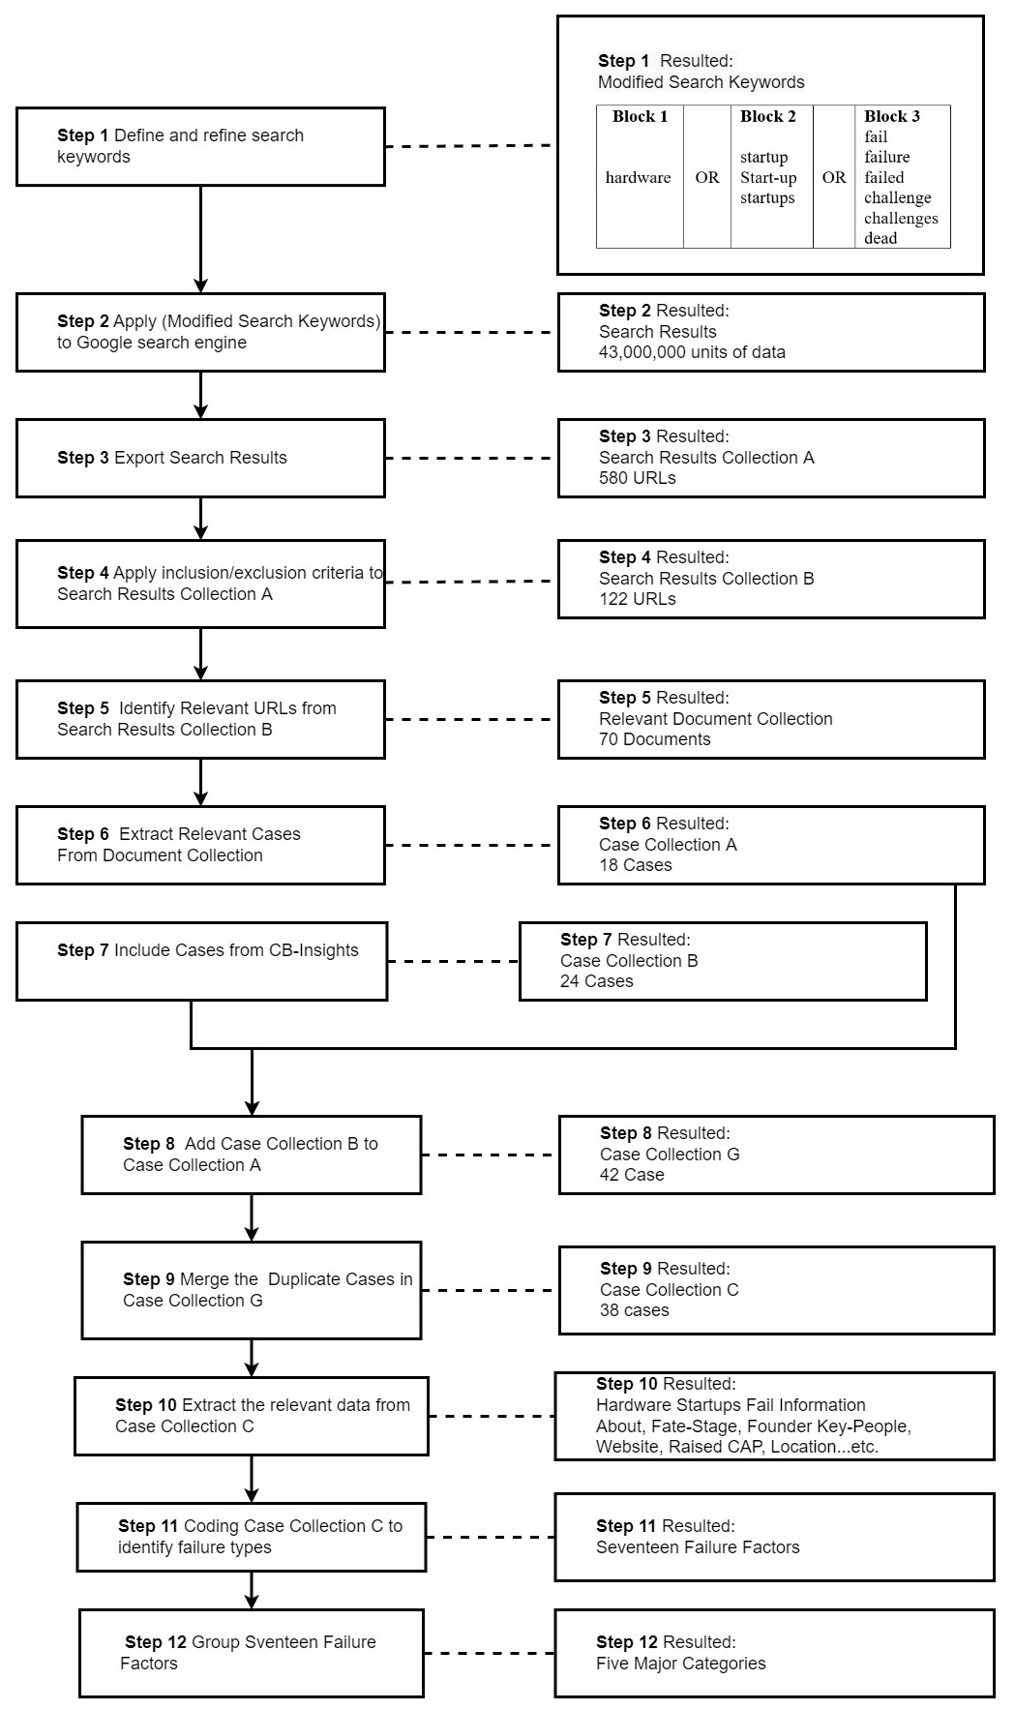

## Phase 1: Data Collection

**Step 1:** Define and refine search keywords for Google:

Table ‎3‑1 In this step, we create three blocks for the keywords. First, we define the keywords, then we refine the string of the search. The step result (1 keyword, 2 keywords, 3 keywords) assigned in (Block 1, Block 2, Block 3) respectively. The step resulted (Modified Search Keywords) as the following:

Table ‑ Define and refine search keywords

|  |  |  |  |  |
| --- | --- | --- | --- | --- |
| **Block 1** |  | **Block 2** |  | **Block 3** |
|  |  |  |  | fail |
|  |  | startup |  | failure |
| hardware | OR | startup | OR | failed |
|  |  | startups |  | challenge |
|  |  |  |  | challenges |
|  |  |  |  | dead |

(” hardware”) AND (“startup” OR “start–up” OR ”startups”) AND (”Fail” OR ”failure” OR ”fails” OR ”failed” OR ”challenge” OR ”challenges” OR ”dead”)

**Step 2:** Apply (Modified Search Keywords) in Google search engine:

The Google search engine was used through the Chrome browser to collect the data from online sources. The step resulted in 43,000,000 units of data in (Search Results).

**Step 3:** Export [Search Results]

In Google Advanced Search, we narrowed the [Search Results] by changing the Language Setting to English only, choosing language English. This step resulted in [Search Results Collection A], which contains 580 URLs (distributed on 17 pages) being displayed and eventually accessible.

**Step 4:** Apply inclusion/exclusion criteria to [Search Results Collection A]:   
To select the website relevant to our study. We implement inclusion/exclusion criteria to process [Search Results Collection A].

* **The inclusion criteria are:** 
  + The website is about hardware startup fail.
  + The URL is not broken and can be accessed.
  + The website language is English.
  + The website must be current, relevant, authoritative, and accurate.
* **The exclusion criteria are:**
  + The website is non-text-based sources (videos, audio), [left for future Work A.9’].
  + The website is on Facebook, Quora, SlideShare, and LinkedIn.

The step resulted in the [Search Results Collection B] containing 122 URLs and reflecting 122 URLs.

**Step 5:** Identify Relevant URLs from [Search Results Collection B]:   
I used the Startups Diagram in Figure ‎2‑1 to identify the relevant information from [Search Results Collection B] and distinguish hardware startups from other startups inside the [Search Results Collection B]. The step resulted in 70 websites being converted into DOC format. The [Document Collection] contains 70 Documents.

**Step 6:** Extract Relevant Cases From [Document Collection]:   
Implement the qualitative analysis of the cases we extracted from [Document Collection]. I read every document in [Documents Collection], Document must reflect hardware startup failure and explain the reason behind why this hardware startup failed. I checked the quality of the [Document Collection] based on assurance quality criteria that were determined by the following:

**A:** Is the document gives why hardware startups fail and includes at least one example of hardware startups failing to support that reason?

**B:** Is the document gives the reason why hardware startups fail and does not include at least one example of hardware startups failing to support that reason?

**Include Case:**   
If the answer to [A] is positive and the answer to [B] is negative. Results: 18 Documents in [Case Collection A] which contains 18 case studies.

**Exclude Document:**   
If the answer to [A] is negative and the answer to [B] is positive. Results: 52 documents are not included Content Analysis, see [A.4].

**Step 7:** Include Cases from [CB-Insights]:   
I include 24 Cases from CB-Insights given to me by Researcher [39]. I used Step 5 and Step 6 to test the 24. This step resulted in 24 Cases in [Case Collection B].

**Step 8:** Combine Case [Collection B] with [Case Collection A]:   
 I combine 18 case studies in [Case Collection A] with 24 Cases in [Case Collection B]. The step resulted in 42 Cases in [Case Collection G].

**Step 9:** Merge the Duplicate Cases in [Case Collection G]:   
I found 4 Duplicated case studies in [Case Collection G]. I find the following duplicate cases: (Jawbone, Lumos, Theranos, and Hello). I merged the duplicate cases. The step resulted in 38 cases studies in [Case Collection C] [A.3]. [40].

## Phase 2: Data Analysis

**Step 10:** Extract the relevant data from [Case Collection C]:   
We read the documents in [Case Collection C] we used NVivo software to extract relevant information about hardware startups failure, the step resulted in (Hardware Startups Fail Information) as the following:

* Founded Year
* Stage-Fate
* Total Raised (CAP.)
* Location, Country, Region.
* Website
* Release date
* Key-People

To collect more information about the hardware startup I visit the Hardware startup failure homepage, Web page, Wikipedia, social media, then I copy and paste the information in the location of the hardware startups fail in NVivo software. Then I used NVivo to code this information to extract the relevant data from them.

**Step 11:** Coding [Case Collection C] to identify the failure factors:   
The step resulted in 17 failure factors. I used thematic analysis tools with NVivo software to extract failure factors from the 38 case study in [Case Collection C]. The step resulted [17 failure factors].

Figure ‎3‑2 (Atlas ti): failure factors extracted from 38 case studies. The data were extracted to identify the factors that caused the hardware startups to fail. The paper will explain failure factors and their case study with details in Chapter ‎4

Figure ‑ Diagram from Gilgamesh Case studies and Failure Factors(Atlas ti version)

**Step 12:** Group [17 Failure Factors]:   
The step resulted in Five Major Categories. 17 failure factors extracted from 38 case studies that have something in common will be organized into identical groups, I will explain this step with more detail later in Chapter ‎4.1.

## Phase 3: Gilgamesh

In this phase, we create a repository at GitHub call it Gilgamesh [2] , it is the official website for this study to store all the research materials and Phase 1 and 2.

Figure ‎3‑3 Gilgamesh repo on GitHub, version control with Visual Studio software.

Figure ‑ Gilgamesh user interface in local machine

# Research Finding

## The Major Failure Factors for Hardware Startups

We find 17 major failure factors for hardware startups that we extracted them from 38 case study A.6. In the following, we grouped the 17 failure factors into five major failure factors category.

Table ‎4‑1 We assigned the failures factors that shared something in common to grouped them into an identical category.

Table ‑ Seventeen Failure Factors assigned in Five Failure Categories

|  |  |
| --- | --- |
| Major Failure Factors Category | Failure Factors |
| #1 Customer and Market | 1. Competition 2. Ignore Customers 3. Lack of demand 4. Lack of interest after initial crowdfunding 5. Poor Marketing |
| #2 Hardware Products and Experts | 1. Domain Expertise 2. Lose Focus No Plan 3. Manufacturing setbacks 4. Poor Product 5. Product Mis-Timed 6. Product strategy mistakes |
| #3 Financial | 1. High burn rate 2. No Financing or Interested Investors 3. Pricing Cost Issues 4. Ran Out of Cash |
| #4 Lack Business Model |
| #5 Legal Issues |

The 17 failures factors is the answer of the research question that we addressed in this study (Why Hardware Startups Fail). We grouped the failure factors in five categories. Nex we will explain with more details every failure factor with an exemplar case.

## Failure Factors Explained with Exemplar Cases

In this section, we will describe each failure factor and all hardware startups that manifested this failure factor, with at least more than one hardware startup as an exemplar case to demonstrate in more detail how this factor caused the failure of that hardware startup.

### Competition

**Description:**  
The consumer hardware space has historically been one in which first-mover advantage is soon wiped away by tech giants following suit with the launch of a similar competing product. Startups looking to gain market share usually struggle against established brand names (P.10 [33]).

**All hardware startups manifested this failure factor:** AOptix Technologies, Jibo, Novelsys, and Pebble (watch).

**Exemplar cases:**

**Pebble Watch**Pebble Technology, a successful Kickstarter, and a Y-Combinator-backed startup, struggled to compete in the wearables space in the face of aggressive marketing and a wide range of alternative watches from competitors like Apple. Pebble was forced to sell its Software and intellectual property to rival smartwatch maker Fitbit, driving Pebble out as a competitor in the space.

### Ignore Customers

**Description:**Ignoring users is a tried-and-true way to fail. Tunnel vision and not gathering user feedback are fatal flaws for most startups. For instance, [eCrowds], a web content management system company, said, "We spent way too much time building it for ourselves and not getting feedback from prospects — it is easy to get tunnel vision. I’d recommend not going more than two or three months from the initial start to getting in the hands of prospects that are truly objective [42].  **All hardware startups manifested this failure factor:**Calxeda, Jawbone, Jibo, Nirvanix, Vinaya, and Zeebo.

**Exemplar cases:   
Jawbone**Jawbone discontinued its relationship with its outside customer service agency after they could not pay for its services, according to Business Insider, failing to replace it with customer service of any kind and angering its remaining customers in the process.   
  
**Jibo**The main reason Jibo failed is that Jibo believes it is a great idea to ignore and cancel international customers’ orders in 45 countries. It is canceling international orders. After initially taking international orders, Jibo in mid-2016 canceled orders overseas. It said it would only ship robots to customers in the U.S. and Canada.

“After exploring all the options, we have concluded that we will not be able to deliver Jibo to your country” because the robot “will not function up to our standards in your country.” International orders add layer upon layer of localization issues: electrical certifications, language, speech recognition, and cultural nuances. Jibo’s solution to these mounting problems was to cancel all international orders and endure customers' disappointment in the 45 countries involved.

### Lack of demand

**Description:**  
Building hardware startup you like, not what the customers like. Building an excellent hardware startup that does not target a specific market need was the factor behind the failure of gaining consumers to buy your excellent hardware startup. In many cases, we noticed that the founders often create products to attract investors but fail to gain customers for their hardware startups [41].

**All hardware startups manifested this failure factor:**Calxeda, Hello, QBotix, and Theranos.

**Exemplar cases:   
Liquavista**  
The motivation behind founding Liquavista was to solve the low battery life faced by devices. It was a huge problem for smartphone makers in the day, so Samsung was eager to buy the company.

However, when Amazon acquired it, the issues associated with mobile battery life had largely been solved as battery lives were improving each year and screens were getting more energy efficient. This reduced the market demand factor for Liquavista’s technology, which never materialized.

**Hello**Hello was a successful startup that raised $210M. Hello shut down because it struggled in a dynamic market. Its product, a beautifully designed intelligent sleep sensor called Sense that helps the user to sleep, created a buzz in tech circles as a desktop sleep monitor, which included a speaker and intelligent assistant, in a market dominated by wearables.

Hello stated that their goal was to ensure users get to optimal sleep environments, but with the launch of smart home devices from tech giants Amazon and Google that offered significantly more functionality on one device at a similar price point, Hello struggled to find a market for Sense.

### Lack of interest after initial crowdfunding

**Description:**  
Crowdfunding platforms like Kickstarter and Indiegogo have been a blessing for consumer hardware startups. They have enabled firms to acquire funds on thin evidence of real capacity to produce a polished product.

In many cases, startups expect to attract institutional investors after a successful crowdfunding campaign to scale up a campaign. However, usually, they are disappointed. The startup project promise is often based on prototypes or pictures, so it is not surprising that many startups fail to deliver, some even failing to offer backers a refund (P.6 [42]).

**All hardware startups manifested this failure factor:**Coolest Cooler, Essential Products, Jawbone, Zano, and ZionEyez.

**Exemplar cases:   
ZionEyez**ZionEyez was looking to raise $55,000, and on July 31, 2011, the closing date for the project, had an astounding performance and spoke to the surprisingly high latent demand for a product such as the one pro- posed by ZionEyez. ZionEyez was a crowdfunding effort toward the release of a marketable pair of glasses with a built-in microphone and camera, which would have been capable of streaming live content to the Internet. The campaign was a phenomenal success when it was held.

ZionEyez wanted 55,000 U.S dollar to fund their project. They received well over 340,000 U.S. dollars by the campaign’s end but fell prey to a common mistake among inexperienced entrepreneurs. They wildly underestimated the money and technical wizardry critical to getting their project off the ground — despite ZionEyez CTO Joe Taylor coming to the company from Flip, which made millions of dollars in the mobile camera market. Slightly exceeded its goal, with 2,106 backers committing a total of 343,415 U.S dollar. **Zano Drones**The original campaign had sought about 190,000 U.S. dollar in funding for a small drone that promised to offer all sorts of features. In addition, the campaign had stretch goals that would unlock additional features if higher amounts of funding were hit. The campaign proved wildly popular, raising about $3.5 million from 12k+ backers during its run.

For a while, the updates were promising, and everything with the campaign seemed fine. Problems started being reported soon enough, though, with various components and issues delaying things. When the Zano drones did finally ship, only a few hundred went out in the first month, and they were sent to those who pre-ordered rather than backers on Kickstarter.

### Poor Marketing

**Description:**Knowing your target audience and how to get their attention and convert them to leads and, ultimately, customers is one of the most important skills of a successful business. The inability to market was a function of founders who liked to code or build the product but who did not relish the idea of promoting the product and came up in 14% of the startup post-mortems [42].  **All hardware startups manifested this failure factor:**Berg, Electroloom, Inq Mobile, Nebula, Nirvanix, QBotix, and Vinaya.  **Exemplar cases:   
Qbotix**Market acceptance and adoption did not happen fast enough to allow QBotix devices to scale.  **Vinaya**This device is made for a specific market, and it is not for everybody. It was unclear how many of its first range of wearables were sold.

### Domain Expertise

**Description:**Wonderful idea, available cash and financial support are not enough to build hardware startups unless you have experts in hardware. The great idea requires experts to implement and build these ideas in the hardware and be experts in some hardware sectors, which does not mean you are an expert in all hardware sectors [43].

**All hardware startups manifested this failure factor:**Lumos, Novelsys, Pirate-3D, and Stratolaunch.

**Exemplar cases:   
Pirate-3D**Reviewing the data we collected on Pirate-3D Founders, they gave a great explanation of why Pirate 3D failed, and those founders had no experience designing Pirate 3D technology. They underestimate the complexity of manufacturing the technology that they attempt to build.

### Lose Focus No Plan

**Description:**Many hardware startups wrote that at the end of their startup experience, when those hardware startups started losing interest, their boards were all wondering where this was eventually going or why they even wanted to run a startup [42].

**All hardware startups manifested this failure factor:**Better Place, and Lumos.

**Exemplar cases:   
Better Place**The Better Place has no plan at all, and they manage to build a product without any idea of what product they are about to build. They have no plan to build a network with no clear understanding of how it functions, so they start building the networks without ordering the drivers that the networks need to function.

A large amount of their money went to buying the networks, so when they noticed that they needed to buy the drivers for these networks, they found that they did not have enough cash to order the drivers again with no plan they decided to order low-cost drivers which are not compatible with the high-cost networks, in the end, they lost the startup.

### Manufacturing setbacks

**Description:**Manufacturing problems rooted in materials, technology, or intellectual property were identified as failure factors (P.5[42]).

**All hardware startups manifested this failure factor:**   
Angel Sensor, and Hello.

**Exemplar cases:   
Angel Sensor** Angel Sensor shut down soon after raising $334K, more than their original goal of $100 [43].

### Poor Product

**Description:**  
Many hardware startup founders have fallen into this factor because they think they can make a profit by selling a low-quality product, not the way around [42].

**All hardware startups manifested this failure factor:**   
Electroloom, Juicero, Novelsys, One Laptop Per Child, Seven Dreamers Laboratories, and Zeebo.

**Exemplar cases:   
Zeebo**  
Zeebo, the console, and the accessories were made cheaply, making them easy to break. The ports of the PS1 games had worse quality than the original counterparts. When it was released, the chart was even lower than the Nintendo Wii, thanks to the Qualcomm processor that is carrion even on Android. The controllers are very uncomfortable. After its failure, Tectoy decided to turn the console into an educational toy, which made the situation far worse. The controllers feel flimsy and cheaply made.

### Product Mis-Timed

**Description:**  
They are not able to release the hardware startup’s product in time. When startups release their hardware too early, the users might think it is terrible, and they will stay away from it.

It will be hard gaining those users again. Releasing the hardware too late means losing the market to other hardware to replace the later hardware [42].   
  
**All hardware startups manifested this failure factor:**   
Calxeda, Jibo, Liquavista, QBotix, Stratolaunch, Theranos, and Vinaya.   
  
**Exemplar cases:   
Jibo**The first sign of Jibo’s problems was delaying shipments frequently. Fast shipment plays an essential part in building a strong relationship between sellers and buyers. The frequent delays forced Jibo to refund the customers for every delayed order, and if you kept delaying the order and did not ship it in time, you will lose your customer trust and they will stop order your hardware and they will order from someone else. In the end, Jibo lose the startup.

### Product strategy mistakes

**Description:**  
Some consumer hardware failures we evaluated made smartphone accessories, and for that reason, their products needed to align with the reference smartphone/tablet. In such cases, updates to both major smartphone platforms, iPhone, and Android, might create unexpected challenges for the product. iPhone accessory company Popslate faced issues when it discovered that the design for its e-ink display iPhone case meant the product was not working as expected. They would need significant product changes before they could ship. Increased R&D expenses coupled with a high burn rate proved it unsustainable for Popslate to continue operations.

**All hardware startups manifested this failure factor:**   
Calxeda, Berg, Better Place, Electroloom, Jawbone, Kolos, Lumos, QBotix, and Zeebo.

**Exemplar cases:   
Calxeda**  
Case study like Calxeda, makes this factor so interest, in our research we find that Calxeda total raised $104.75M, to produce the ARM hardware that failed. Calxeda is interest case, the company is not only high raised, but Calxeda is powered by Intel, Intel is a well knowing industry with a vast background of experts in producing CPU, Intel was the first industry in the glob that invented the CPU, with $104.75M total raised, and with Intel backup.   
  
But Calxeda failed to produce the ARM CPU and make Intel upset, because Calxeda didn’t avoid the product strategy mistakes, Calxeda Devs they decide that it is a good idea and strategy to keep producing ARM CPU with 32 bit as a rock sold stable CPU with low power and balance efficiency, Calxeda believe it is terrible idea to lean toward ARM with 64bit to target new market new users.   
  
Even when all the evidence shows to the Calxeda CEO that the users, small business are upgrading their devices from 32bit to 64bit, and ARM 64bit bench- mark came with low power with high performance efficacy and beat ARM 32bit.

The drama that left Calxeda’s ARM behind and Intel experts hopeless, which make the Calxeda worst that after Calxeda CEOS acknowledge that they did Product strategy mistakes, but their excuse is blaming the users and the small business for the strategy mistakes that done by Calxeda.

Calxeda admitted that they make a troubling strategy, but Calxeda excuse is far way worst from the guilt of following a bad strategy when Calxeda said the ARM 32-bit failed because they moved faster than the Linux users by producing 1980s 32bit while the Linux users shifting from 32 to 64bit in Calxeda announcement.

They keep saying this excuse: ARM 32-BIT is the future, and ARM 64-BIT is from the past. It is like saying 1 CM is greater than 1 K.M. and living in the 1940s is living in the future and living in 2023 is living in the past. Which make this expression” The Excuse is far worse than guilt” is fit to Calxeda case.

Producing hardware is hard than Software, and Hardware startups are hardest; Calxeda & Intel case study is a good example.

” Q: Did Calxeda and Intel Corp. make this mistake in purpose?”

Answering the other part of the question will explain the differences between building software and hardware, why producing hardware startups is the hardest, and our research question why hardware startups fail.

No is the short answer, and my research didn’t find any physical evidence or material that said Intel or Calxeda, they made the strategy mistakes in purpose, the opposite we find that Intel and Calxeda kept finding tell the end to build successful ARM CPU, but, when Calxeda announced the failure this mean Calxeda already bought the ARM parts to build the 32-bit chip, and they already signed the contract with Red Hat Enterprise to run and test Red O.S. on the ARM 32-bit Chip.

Even if Intel & Calxeda knew they made strategy mistakes, but there is no way back because the hardware parts were bought, and the contract was signed. The output for our data startups, analytic to the Intel and Calxeda case, tells us why building hardware is hard than building a software product, and building a successful hardware startup is hardest than building software startups.

### High burn rate

**Description:**  
It is the monthly rate of spending money without recovering it (e.g. Anki and Aquion Energy [44] [45]).

**All hardware startups manifested this failure factor:**   
Better Place, Kolos, Pearl Automation, QBotix, and Vinaya.

**Exemplar cases:   
Pearl**  
Pearl was a successful startup founded by Apple veterans; Pearl Automation succumbed to an unsustainable burn rate in a market not quite ready for their product. The Bay Area startup raised about $50 million from investors, including smart money V.C. Accel Ventures but claimed it needed several hundred million dollars more to develop the market for its product line of rear-facing and front-facing car cameras.

### No Financing or Interested Investors

**Description:**  
This factor is the side effect of running out of money, as what we understand from the data that we reviewed, that the investors are not interested in spending their money on to support and to financially support the hardware product, you cannot expect financial support to the hardware startups from the investors if the startups’ founders failed to encourage those investors to them pour their money on the product [42].

**All hardware startups manifested this failure factor:**   
Angel Sensor, Anki, Aquion Energy, Jawbone, Lily Robotics, and SCHAFT.   
**Exemplar cases:   
Schaft**  
Schaft couldn’t find investors to provide growth capital in Japan and asked Google for help. The company won first place in a robot technology contest hosted by the U.S. Department of Defense immediately after it became part of Google. It also has drawn attention as an example that Japanese investors could not spot the potential of promising technology and let it flow overseas.

### Pricing Cost Issues

**Description:**  
What we learn from this factor that the startups founder they miscalculated the cost and amount of money that they should to spend on hardware to gain a profit in return [42].

**All hardware startups manifested this failure factor:**   
Airware Drone, AOptix Technologies, Better Place, Jawbone, Lumos, Nebula, Novelsys, Vinaya, and Zeebo.  
  
**Exemplar cases:   
Zeebo**  
For Brazilian customers this startup was expensive, Zeebo costing 500 U.S, dollar, and at launch around 250. This price is low compared to other consoles sold in Brazil, but considering all the downgrades the console had, it wasn’t enough. To add insult to injury, it had a budget price in Mexico, costing $2000 MXN, which is just US$150 at the time. The startup console failed so badly that nowadays, it can cost more than $300. If the console has all the available games, the price will rise a lot.

### Ran Out of Cash

**Description:**  
From several documents that we collected, we find that the failed startups describe this factor as follows, in the first stage, they fail to secure financial support for their startup, then startup money runs out. Our understanding is that there is a connection between securing money for the hardware startup and between running out of money [42].

**All hardware startups manifested this failure factor:**   
Airware Drone, Anki, Aquion Energy, Electroloom, Fuhu, QBotix, and Vinaya.

**Exemplar cases:   
Airware Drone**   
Airware Drone was a successful startup, the startup raised more than one and a half million U.S dollar, they failed because and they run out of the money, because they decide to invest in competing a Chinese Drone company that’s ten times bigger than Airware.

### Lack Business Model

**Description:**  
The studies we read in hardware startups said that: “No one put their money on business that has no model to start with.” Lack of business model factor causes the failure of their product. A flawed business model affects the investors and makes them confounded. The investors will be unwilling to put their money on that startup. Especially if those investors find that the hardware startup did not show a business model that can trust put their money on it[42].

**All hardware startups manifested this failure factor:**   
Electroloom, and Lumos.

**Exemplar cases:   
Electroloom**  
Electroloom startup was the clothes-printing. Failed because of lack of MVP as Lumos’s CEO said.

**Lumos**  
In article published by Lumos Co-Founders, they explained with detail how ’Lack Business Mode’ caused the failure of their product. Lumos Co-Founders said that they did not understand the market, they build the product based on assumption, without selling the first product to the customers.

### Legal Issues

**Description:**  
Illegal, or unlawful, typically describes something that is explicitly prohibited by law (e.g., Money laundering, Criminal Fraud, tax evasion, false accounting ...etc.) [42].

**All hardware startups manifested this failure factor:**   
Aquion Energy, Better Place, Coolest Cooler, Essential Products, Jawbone, Njoy, and Theranos.   
  
**Exemplar cases:   
Theranos**Holmes was found guilty of three counts of wire fraud and one count of conspiracy to commit wire fraud.

**NJOY**  
We can say with confidence NJOY story is a story of American double standard law and regulation for Smoking business; Smoking in Marlboro is okay, smoking an e-cigarette is not okay. A notable startup affected by looming FDA regulations against the growing e-cigarette market was Arizona-based NJOY. Backed and endorsed by popular singer Bruno Mars among many other investors, NJOY was one of the first to launch an e-cigarette with their popular product KING, which saw a significant decline in sales following FDA regulatory changes. NJOY struggled to continue operations, filed for bankruptcy, and sold its assets soon after.

**Coolest Cooler**   
In 2016, the Oregon Department of Justice opened investigations into Coolest Cooler for unlawful trade practices. A year later, Cooler settled with the Oregon DOJ and ultimately committed to refunding its jilted backers a whopping $20 each. Because the company was effectively bankrupt at this point, it is unclear whether backers received this money.

# Discussion

## Most Critical Hardware Startup Failure Factors

* **Product strategy mistakes**

This factor is the most frequent failure factors for our study. Intel and Google will not prevent the hardware startups from failing because of this factor. We found that even if powerful industries like Intel and Google back up the hardware startup, they did not consider Product strategy mistakes.

* **Pricing Cost Issues**This factor gives us an idea of why hardware startups are challenging. This factor gives us a clear answer for the following question How hard the hardware startups hard. This failure occurred because of the following cost: Hardware parts, manufacturers, shipping these parts, TAX, and VAT, making these different parts work together at once, finding the right technicians to build these parts...etc.
* **Poor Product**This factor shows that hardware startups must distinguish between cheap and in- expensive products. This factor appears whenever startups build a cheap product with poor quality, they might avoid this factor by building inexpensive products with average quality.

## Limitations of the study

The nature of the study and the strategy option made before and during working on this research, impacted not only the research’s results, but also some possible limitations that I already knew them even before start working in this project.

### Lack of previous research studies on Hardware startups failures

Finding previous studies related to hardware startups failure will help to learn and understand the current state of the problem. Lack of previous study can serve as an important opportunity to describe the need for further research on (hardware startups fail) and this gap. Indeed, Lack of previous study is so important, it encouraged me to work on this research to discover a new possible way to solve the hardware startups failure problem, and to fill.

### Gray Literature’s Secondary and Self-reported Data Collection

I developed three phases strategy for this research relied on Gray Literature to save time, provide large and higher-quality secondary data, I used thematic analysis to process the data. However, the data represent people interview and their opinions on why hardware startups fail, this limited the study because it is not primary data, moreover I must take what people say and the data it might contain several potentials of bias.   
  
I choose to be limited by Self-reported data over the lack of previous research to surpass the lack of previous research studies on Hardware Startups Failure, and to move forward with this research.

Self-reported data fits with the nature of this study, works well with thematic data analysis, and saves time and money. Moreover, the three phases strategy fit the nature of the Self-reported data that I processed in this research.

# Conclusions, implications of the study and directions for future research

## Conclusion

In this study we provides a taxonomy of context of factors of hardware startups related to both the hardware startups and the researchers and their definitions, classification and collecting and analysis of over 43,000,000 unites of data only in the initial stage, and processing of over 38 case study and 52 content analysis over these failure factors, guidelines on how to choose the choose failure factors based on any set of data, and how to process them by the Thematic analysis tools and determine relevant results, that could express information in a more straightforward way, or in a way that makes the hidden information in the dataset obvious. I present our process as a possible way of establishing a process to generate frequent sets of factors to the fallen hardware startups from data and their context information.

Furthermore, this process could now be considered a humble starting point for thorough discussions about alternative approaches and new ideas to understand better why the hardware and the startups in general often fail.

## Implications for future research

To modify the current research, I suggest implications for the future work, as the following:

1. Implications on Thematic Analysis of Video and Audio Data [46].
2. Implications on Adjusting Search Keywords in Gray Literature and Secondary Data.

These implications will take advantage improve the depth and the width of the future research.

### Implications on thematic data analysis with video and audio

Considering thematic analysis on video and audio data side by side with text formats to extract study cases and failure factors in video, audio, and text format. The thematic analysis on video and audio data will help the future research to bypass the limitation of Lack of previous research studies on Hardware startups failures and minimizing the risk of using the Self-reported data on hardware startups failures. Thematic analysis on video and audio data gives the opportunity to collect data from different resources.

### Implications on Adjusting Search Keywords in Gray Literature

Adjusting Search Keywords in Gray Literature and (Secondary Data), by defining and refine new keywords of the Gray Literature to include the A.I. and IoT hardware startups in the data collection. This new suggestion will move the Gray Literature to the next level to collect data from famous industries like Intel and Ubuntu. This research shared the same interest in A.I. and IoT hardware startups with Intel and Ubuntu [47] [48].

Example: Adjusting Search Keywords in Gray Literature and Secondary Data:

IoT, AI, CPU, Mouse, Monitor, Keyboard, Headphone, Laptop

# Bibliography

|  |
| --- |
| [1] R. Eric, “The Lean Startup.”  [2] Forbes Advisor, “What Is A Startup? How Do Startups Work?” https://www.forbes.com/advisor/investing/what-is-a-startup/#544a2a9a4c63 (accessed Oct. 19, 2021).  [3] S. Vocabulary, “the physical and electronic parts of a computer, rather than the instructions it follows,” pp. 1–7.  [4] J. Stoltzfus, “What is Hardware?,” *techopedia*, 2020. https://www.techopedia.com/definition/2210/hardware-hw (accessed Feb. 26, 2022).  [5] Tom Eisenmann and T. Eisenmann, “Why Start-ups Fail,” *Harvard Business Review*, 2021. https://hbr.org/2021/05/why-start-ups-fail (accessed Aug. 30, 2021).  [6] Lydia Ramsey Pflanzer, “The History of $9 Billion Theranos and CEO Elizabeth Holmes,” *Business Insider*, 2019. https://www.businessinsider.com/the-history-of-silicon-valley-unicorn-theranos-and-ceo-elizabeth-holmes-2018-5?r=US&IR=T (accessed Feb. 21, 2022).  [7] Joseph Rago, “A Drop of Blood. An Instant Diagnosis, The Wall Street Journal,” 2013. Accessed: Feb. 19, 2022. [Online]. Available: https://www.wsj.com/articles/elizabeth-holmes-the-breakthrough-of-instant-diagnosis-1378526813  [8] Elizabeth Holmes, “Elizabeth Holmes, Theranos CEO at TEDMED 2014.” https://www.youtube.com/watch?v=ho8geEtCYjw (accessed Feb. 19, 2022).  [9] TechCrunch, “Getting Blood Work Done with Elizabeth Holmes of Theranos | Disrupt SF 2014 - YouTube,”  *Jon Shieber*. https://www.youtube.com/watch?v=AaTHtSy5le4 (accessed Feb. 19, 2022).  [10] Jonathan Symonds, “GSK.” https://www.gsk.com/en-gb/home/ (accessed Feb. 19, 2022).  [11] H. Jeffer, “A list of the names represents Theranos most accomplished, board.” https://github.com/HeiderJeffer/Gilgamesh/blob/master/List of the names represent Theranos most accomplished board.md (accessed Oct. 14, 2022).  [12] Sophia Kunthara, “A Closer Look At Theranos’ Big-Name Investors, Partners And Board As Elizabeth Holmes’ Criminal Trial Begins,” 2021. https://news.crunchbase.com/news/theranos-elizabeth-holmes-trial-investors-board/ (accessed Feb. 21, 2022).  [13] Charles Pfizer and Charles F. Erhart, “Pfizer: One of the world’s premier biopharmaceutical companies.” https://www.pfizer.com/ (accessed Feb. 19, 2022).  [14] A. Salzman, “From Unicorn Hype to ‘Massive Fraud,’” 2018. [Online]. Available: http://www.djreprints.com.https//www.barrons.com/articles/  [15] E. E. S. M. C. W. JINA L. CHOI, “ELIZABETH HOLMES and THERANOS - Defendants.,” no. COMPLAINT, 2018.  [16] and E. W. Erin Griffith, “Theranos Founder Elizabeth Holmes Found Guilty of Four Counts of Fraud,” Jan. 03, 2022. https://www.nytimes.com/2022/01/03/technology/elizabeth-holmes-guilty.html (accessed Feb. 21, 2022).  [17] U. Cenk and K. Ana, “Elizabeth Holmes Found GUILTY Of Fraud,” *TYT*. https://www.youtube.com/watch?v=y4vqKrVFiP0 (accessed Feb. 19, 2022).  [18] CB-Insights, “Why Startups Fail: Top 12 Reasons,” 2021. https://www.cbinsights.com/research/startup-failure-reasons-top/ (accessed Feb. 21, 2022).  [19] K. Slovensko spol ro, “Startup Ecosystem Survey 2016,” 2016.  [20] Barry Ritholtz, “San Diego Source > Technology > Learning lessons from failures of tech startups - Bloomberg.” http://www.sddt.com/Technology/article.cfm?Sourcecode=20150611faa&_t=Learning+lessons+from+failures+of+tech+startups (accessed Feb. 18, 2022).  [21] Ian King, “Intel Loses Market Share in Server Chips But Makes Gains in PCs (INTC) - Bloomberg.” Accessed: Feb. 18, 2022. [Online]. Available: https://www.bloomberg.com/news/articles/2022-02-09/intel-loses-market-share-in-server-chips-but-makes-gains-in-pcs  [22] Thomas Alsop, “• Lenovo PC market share by quarter 2021 | Statista”, Accessed: Feb. 18, 2022. [Online]. Available: https://www.statista.com/statistics/255306/global-pc-market-share-held-by-lenovo-since-the-1st-quarter-2009/  [23] Lenovo, “Small Business Technology Solutions for Start Ups | Lenovo Tech Today United Kingdom.” https://techtoday.lenovo.com/gb/en/solutions/smb/startups (accessed Feb. 18, 2022).  [24] T. Stock and G. Seliger, “Methodology for the Development of Hardware Startups,” *Adv. Mater. Res.*, vol. 1140, no. August 2016, pp. 505–512, Aug. 2016, doi: 10.4028/www.scientific.net/AMR.1140.505.  [25] A. Nguyen-Duc, X. Weng, and P. Abrahamsson, “A preliminary study of agility in business and production: Cases of early-stage hardware startups,” *International Symposium on Empirical Software Engineering and Measurement*. 2018. doi: 10.1145/3239235.3267430.  [26] E. Griffith, “Why Do Startups Fail? Because Hardware is Hard,” *Wired*, 2017. https://www.wired.com/story/why-do-startups-fail-because-hardware-is-hard/# (accessed Aug. 04, 2021).  [27] Z. Li and W. Seering, “Does open source hardware have a sustainable business model? An analysis of value creation and capture mechanisms in open source hardware companies,” *Proc. Int. Conf. Eng. Des. ICED*, vol. 2019-Augus, no. August, pp. 2239–2248, 2019, doi: 10.1017/dsi.2019.230.  [28] J. Murray, “What Is Cash Flow?” https://www.thebalancemoney.com/cash-flow-how-it-works-to-keep-your-business-afloat-398180 (accessed Oct. 15, 2022).  [29] W. Croft and D. A. Cruse, *Cognitive Linguistics*. Cambridge University Press, 2004. doi: 10.1017/CBO9780511803864.  [30] EBAN European representative, “EBAN – Europe’s leading early stage investors network.” https://www.eban.org/ (accessed Feb. 18, 2022).  [31] I. R. Bednár and I. N. Tarišková, “Indicators of startup failure,” vol. 240, no. 5, pp. 238–240, 2017.  [32] CB-Insights-TECH, “CB Insights - Technology Market Intelligence.” https://www.cbinsights.com/ (accessed Feb. 18, 2022).  [33] CB Insights, “Top 20 reasons Startups fail,” *CB Insights*, pp. 1–9, 2018, [Online]. Available: https://www.cbinsights.com/research/startup-failure-reasons-top/  [34] CBInsights, “Top 12 Reasons Startups Fail,” *CB Insights*, pp. 1–26, 2021, [Online]. Available: https://www.cbinsights.com/research/startup-failure-reasons-top/  [35] Red Hat, “Red Hat - We make open source technologies for the enterprise.” https://www.redhat.com/en (accessed Feb. 18, 2022).  [36] ANUP CHATHOTH, “Hardware isn’t hard: A startup playbook for succeeding in a sector where many have failed,” *GeekWire*, 2020. https://www.geekwire.com/2020/hardware-isnt-hard-startup-playbook-succeeding-sector-many-failed/ (accessed Mar. 04, 2022).  [37] C. Freeman, “Grey Literature: What is grey literature”, Accessed: Feb. 18, 2022. [Online]. Available: https://guides.lib.monash.edu/grey-literature/whatisgreyliterature  [38] U. Rafiq, J. Melegati, D. Khanna, E. Guerra, and X. Wang, “Analytics mistakes that derail software startups,” in *ACM International Conference Proceeding Series*, Jun. 2021, pp. 60–69. doi: 10.1145/3463274.3463305.  [39] S. S. Bajwa, X. Wang, A. Nguyen Duc, and P. Abrahamsson, “‘Failures’ to be celebrated: an analysis of major pivots of software startups,” *Empir. Softw. Eng.*, vol. 22, no. 5, pp. 2373–2408, Oct. 2017, doi: 10.1007/S10664-016-9458-0.  [40] H. Jeffer, “Outcome of Extracting the relevant data from Case Collection B,” *Gilgamesh*, 2022. https://github.com/HeiderJeffer/Gilgamesh/blob/master/Outcome of Extracting the relevant data from Case Collection B.pdf (accessed Mar. 04, 2022).  [41] CB-Insights, “T0p 9 and Top 20 Reasons Startups Fail,” New York.  [42] CB-Insights, “The Top 9 Reasons Hardware Startups Fail.”  [43] Angel, “Angel Sensor.” 2019. [Online]. Available: https://angel.co/company/angel-sensor  [44] “Anki.”  [45] T. R. Eisenmann and D. Kiron, “Aquion Energy,” *Harvard Business School Entrepreneurial Management Case No. 811-047*. 2011. [Online]. Available: http://papers.ssrn.com/abstract=2018292  [46] K. , E. Ramey, J. Hilppö, E. Dyer, and C. Krist, “Qualitative Analysis of Video Data: Standards and Heuristics.” https://www.researchgate.net/publication/319965247_Qualitative_Analysis_of_Video_Data_Standards_and_Heuristics (accessed Oct. 16, 2022).  [47] Intel, “Artificial Intelligence Startups - Launch with Intel.” https://www.intel.com/content/www/us/en/analytics/artificial-intelligence/artificial-intelligence-startups.html (accessed Feb. 18, 2022).  [48] Ubuntu, “Ubuntu for the Internet of Things.” https://ubuntu.com/internet-of-things (accessed Feb. 25, 2022). |

# APPENDIX

## PAPER-PROTOTYPE

A Paper-prototype - first activity

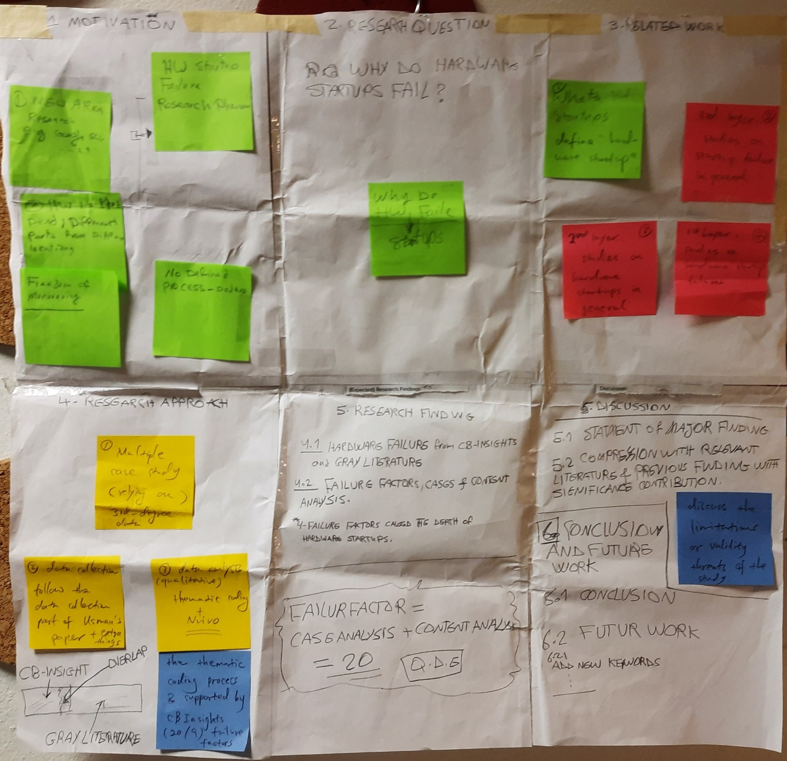

A Paper-prototype - second activity - Processing the Data Collection

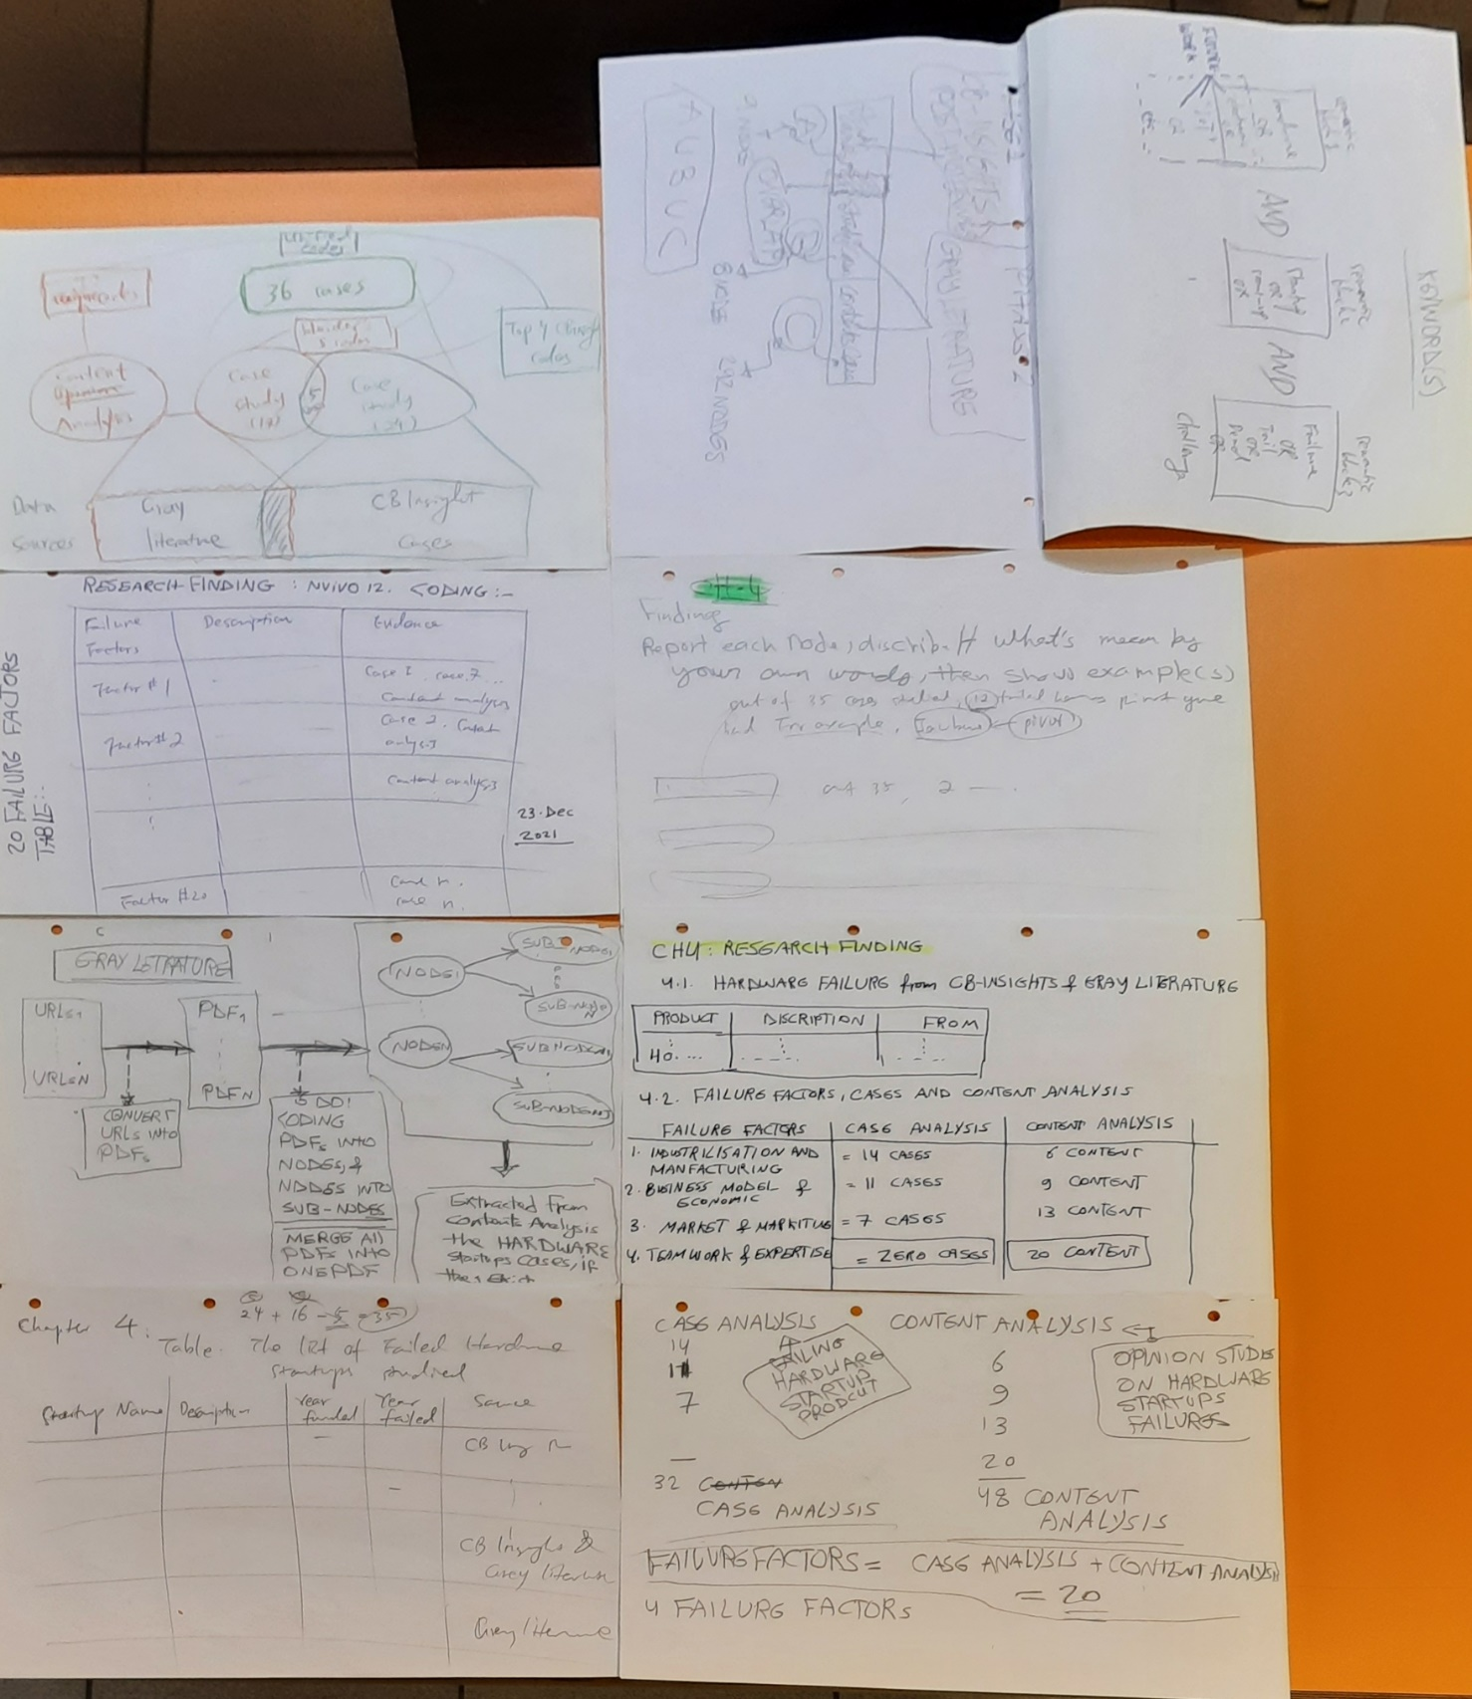

## Data collection and Data Analysis with NVivo Software

A Data Analysis: 38 Case in [Case Collection A] - NVivo

A NVivo: 52 Content Analysis

A Future Work: Coding the 52 Content Analysis, NVivo

A 17 failure factors extracted from 38 case study, NVivo

A Groping 17 failure factors into 5 major categories, NVivo

A Extracting Hardware Startups Fail information, NVivo

A Future Work: including video and audio in the data collection

## Data of [Case Collection B]

You can the output of: Extracting the relevant data from Case Collection B, in Gilgamesh at:

[https://github.com/HeiderJeffer/Gilgamesh/blob/master/Outcome%20of%20Extracting%](https://github.com/HeiderJeffer/Gilgamesh/blob/master/Outcome%20of%20Extracting%20the%20relevant%20data%20from%20Case%20Collection%20B.pdf) [20the%20relevant%20data%20from%20Case%20Collection%20B.pdf](https://github.com/HeiderJeffer/Gilgamesh/blob/master/Outcome%20of%20Extracting%20the%20relevant%20data%20from%20Case%20Collection%20B.pdf)

1. https://ieeexplore.ieee.org/search/searchresult.jsp?newsearch=true&queryText=hardware%20startups%20fail
2. https://github.com/HeiderJeffer/Gilgamesh